24th May 2017

**YOKOHAMA’s “BluEarth” to Come Factory-Equipped on new Subaru XV**

YOKOHAMA announced today that it has begun deliveries of its “BluEarth E70" to Subaru Corporation for use as the original equipment tyre on the automobile maker’s all-new Subaru XV. The tyre size is 225/60R17 99H. Subaru Corporation launched the new model in Japan on 24th May 2017, with subsequent rollouts worldwide. In Japan, the new model also comes equipped with YOKOHAMA’s emergency flat-tyre repair kit.

The “BluEarth E70” is an ideal summer tyre for passenger cars. The tyre features the basic design and materials technology used in the YOKOHAMA’s “BluEarth” global tyre brand, which is based on the concept of “environmentally, human, and socially friendly”. The “BluEarth E70” delivers a safe, comfortable ride while also enhancing vehicle’s fuel efficiency.

The all-new Subaru XV is a crossover SUV that combines a stylish urban design with enhanced drivability in the toughest conditions and world-class safety performance. The all-new Subaru XV features Subaru’s next-generation platform, the Subaru Global Platform, which greatly enhances vehicle safety and driving performance.

YOKOHAMA has been dynamically developing tyres employing its leading-edge “BluEarth” tyre technology, and many of these tyres have been adopted by automakers as original equipment, especially on new eco car and hybrid vehicles.

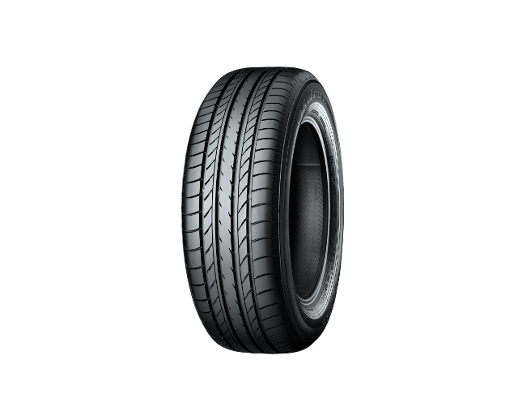

*BluEarth E70” Size shown is different from that used on Subaru XV*